Bachelor’s Thesis

Inline 3D Scanning Prototype System   
for Industrial Part Inspection with 2D Camera and Line Laser

A Bachelor’s Thesis

Submitted to the School of

Mechanical and Control Engineering of

Handong Global University

Author Name: Yunki Noh

December 2024

This certifies that the bachelor’s thesis is approved.

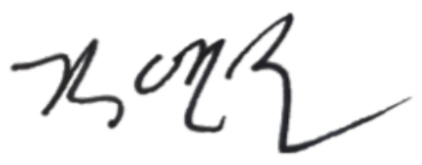

[]

___________________________

Thesis Advisor: Ph.D. Young-Keun Kim

[

___________________________

The Dean of Faculty: Ph.D. Chong-Sun Lee

School of Mechanical and Control Engineering

Handong Global University

December 2024

Table of Contents

|  |  |  |  |  |  |  |  |
| --- | --- | --- | --- | --- | --- | --- | --- |
| **Extended Abstract** | | | | ························································· | | | **i** |
|  | | | |  | | |  |
| **I. Indrodution** | | | ·································································· | | | | **7** |
|  | | | | | | | |
| **II. Method of Experiment** | | | | ························································· | | | **8** |
|  | **2.1.** Laser Triangulation | | | | ················································ | | **8** |
|  | | 2.1.1. Laser Triangulation | | | | ········································ | **8** |
|  | | 2.1.2. Perspective Distortion | | | | ········································ | **9** |
|  | **2.2.** 3D ScanningSytem | | | | ················································ | | **10** |
|  | | 2.2.1. Hardware | | | | ········································ | **10** |
|  | | 2.2.2. Software | | | | ········································ | **12** |
|  | | | | | | | |
| **III. Result of Experiment** | | | | ························································· | | | **17** |
|  | **3.1.** Defect Inspection | | | | ················································ | | **17** |
|  | | 3.1.1. 3D Scanning Result | | | | ········································ | **17** |
|  | | 3.1.2. Defect Inspection | | | | ········································ | **18** |
|  | **3.2.** Limitations of This System | | | | ················································ | | **19** |
|  | | 3.2.1. Unit Distance between Each 2D Image | | | | ········································ | **19** |
|  | | 3.2.2. Slope Distortion | | | | ········································ | **20** |
|  | | | | | | | |
| **IIII. Conclusion** | | | ································································· | | | | **21** |
| Reference | | | ································································· | | | | **22** |
|  | | | | | | | |

**Extended Abstract**

Inline 3D Scanning Prototype System for Industrial Part Inspection with 2D Camera and Line Laser

In the industrial area, defect inspection for product must be performed to ensure the quality of the product. In the common method to accomplish this task, 3D camera has been used to inspect defect with the height information about the product. In fact, there are already several kinds of 3D scanning methods. Above all, the optical 3D scanning method provides most precise scanning result: ToF (Time of Flight), Structured Light Scanning, and Laser Triangulation. Among these three optical methods, the laser triangulation method provides the highest precision with micrometer scale. Actually, to inspect industrial parts of millimeter scale, most industry has used specially designed equipment for laser triangulation method. In fact, these types of 3D cameras are expensive, and it is not easy to use the laser triangulation 3D scanning equipment for non-business purposes because of the high cost. However, the laser triangulation does not need very complicated theory and devices to get 3D scanning results. Actually, if there are 2D Camera, Telecentric Lens, and Line Laser, laser triangulation would be able to be realized even in the laboratory of the university. For this reason, I planned to build up the laser triangulation 3D scanning system using 2D camera in this project. Especially, I planned to inspect defect of small products in micrometer scale.

To build up environment for laser triangulation method, several hardwares were used in this project: 2D Machine Vision Camera, Telecentric Lens, Line Laser, and Conveyor Belt. At first, to prevent optical disturbance occured from outside lights other than lasers, five sides of this system were surrounded by five flat plates. After blocking the possibility of scattering of external light, other devices are fixed at predetermined positions. The telecentric lens is combined with 2D camera at a distance of 130mm from the ground of conveyor belt. The line laser is also fixed by their side at the angle of $70.5°$. At this point, this line laser must be unified with an initial parallel line on the 2D camera’s image. After fixing 2D camera, telecentric lens, and line laser at the predetermined position and angle, the conveyor belt would be fixed on the ground of this system. This conveyor belt would carry each samll industrial part under the line laser. When the object is passing under the line laser, the lasers would move from the initial parallel line according to the height of this object.

In this hardware setting, the 2D camera would be able to receive each source image through telecentric lens and 2D camera. However, this machine vision camera needs Pyspin library to deal with the source image in python environmet. After installing Pyspin, the source image would be processed in three steps of the softwre system: image capture, image processing, and 3D plotting. At first, the source image would be RGB scale, and this image needs to be converted into gary scale to extract pixels of line laser. Then immediately this gray scale image would be filtered by threshold function (250~255 passing). Because pixels of line laser would be brightest than other points, line laser points would remain and other points would be removed from the gary scale image. However, lots of optical noises occurred due to the scattering of the line laser. Because these nosies would interfere with precise calculation of height value, I removed these noises using median filter. And lastly, to calculate displacement distance of the line laser from the initial parallel line, y pixels of the line laser in the same column were averaged. After this process, the line laser would be converted into a fine line which has only one pixel per column, and by using this fine line, each height value of object would be calculated. With the information of height value, the object would be scanned in 3D.

In this system, several objects were able to be scanned in 3D: Gear, Flat Joint, Cap, and Cricle Part. Especially, gear and frame were used to check the defect inspection. At first, I scanned the normal state of gear and frame. When it comes to the flat surface of these objects, the overall shapes were performed well. By using the 3D information about their flat side, I could check the normal state of each part. Second, defective state of gear and frame were also scanned from this system. Because each defect was marked on the flat surface, defects were also scanned well. As a result of this, the normal state and defective state were distinguished well through the 3D scanning result. However, there are some limitations of this system: Moving distance of the conveyor belt problem and Slope distortion problem. Both are about the length distortion of 3D scanning. Because I set the resolution of source image in 375x375, the unit distance of each pixel (y, z axis) becomes 0.1mm. To unify the unit distance of this system, I also tried to set up the unit distance of x axis as 0.1mm. To do this, the fps value needs to be set in consideration of the velocity of the conveyor belt. When I checked the velocity of conveyor belt, the velocity was almost 7.5 mm/s. With the 7.5mm/s velocity of the conveyor belt, the 2D camera needs to be set 75 fps to make unit distance between each 2D image as 0.1mm. However, because of the unstable state of the conveyor belt depending on the voltage, the unit distance was not exactly match 0.1mm scale. In addition to this, I could not check the accurate velocity of conveyor belt using each image captured from the 2D camera. As a result of this, the length of 3D scanning becomes shorter than the actual length of object. To solve this problem, conveyor belt which can manipulate it’s velocity precisely need to be used in this project, and also the velocity must be measured using images captured by 2D camera. In addition to this, because tightness which the line laser would perform on the surface of each object would be different, the length of each side of different anlgles also would be distorted comparing with the actual length value of the object. To solve this problem, this system needs to scan only low height and low slope of small objects, and the line laser needs to be fixed near to $90°$ of angle. Although there are several problems and limitations of this system, with some improvements, 0.05mm precision would be able to be realized.**I. Indrodution**

In the industrial area, defect inspection is a important process to ensure state of product’s quality. Traditionally, 3D cameras have been used to get 3D scanning result to inspect defects of products. Especially, although there are several methods for 3D scanning, the optical method of 3D scanning is adequate for preicse inspcetion of small industrial parts. Among the several optical 3D scanning methods, the laser triangulation method is most precise. For this reason, in the industrial factory, 3D scanning equipments of laser triangulation method have been used to inspect defect of small parts. However, these type of equipments are expensive. Because of the high cost of them, it is not easy to use them for non-industrial purposes. However, although they are very expensive (almost over 10 million won per single 3D camera), the laser triangulation can be realized if high resolution of 2D camera, telecentric lens, and fine line laser can be used. If the 3D scanning system can be built up with these devices, the laser triangulation method would be able to be used in the laboratary scale in the university, because the cheaper cost of them. In addition to this, these devices are basic equipments in the vision machine lab in the scale of university. For this reason, I planned to build up the 3D scanning system of the laser triangulation method based on the 2D camera.

To build up overall system for 3D scanning, the system was divided into two sections: Hardware setting, and Software setting. In this system, 2D machine vision camera of 2048x2048, Telecentric lens, Line laser of 450nm, and Conveyor belt were used. The lens is combined with camera, and fixed 130mm away from the bottom of the conveyor belt to focus on each object. The line laser is fixed the left side of the camera at adequate predetermined angle. And this laser must to be projected on the bottom along the initial parallel line. After fixing all of the optical devices and fixing the conveyor belt under these optical devices, the five sides of this system would be surrounded by five flat plates to prevent outside optical disturbances. To receive and process source images with the machine vision camera, the Pyspin library must be installed. With Pyspin, every source images would be captured by camera, and after several image processing about these images, the height value would be able to be calculated. By using the height values, 2D images would be made, and with the stack of hundreds of the 2D images, the 3D scanning would be performed. By extracting 3D scanning result through this system, I would check the defect status of some objects. The 3D scanning results would be imperfect because of several limitations and problems of this system: Unit distance between each 2D image problem and Slope distortion problem. However, I will make some suggestions for improvement about these limitations of this system.

**II. Method of Experiment**

**2.1. Laser Triangulation**

2.1.1. Laser Triangulation

Laesr triangulation method is based on the tirangulation method. Triangulation method is for the calculation of the unknown length of a triangle’s side using already-informed two sides and the included angle.

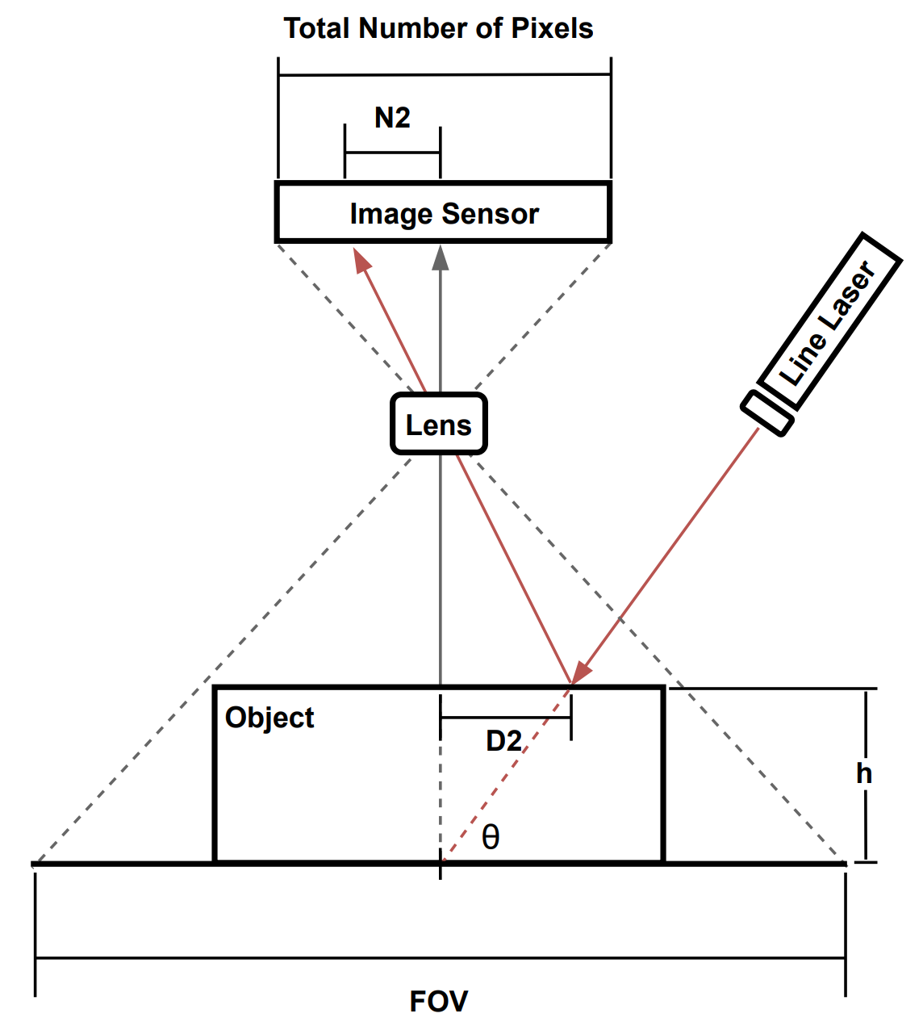

**Figure 1. Laser Triangulation**

By using triangulation method, the height value of small object can be calculcated with 2D camera and line laser. The line laser will be projected on the perdetermined parallel line of the image captured by 2D camera with fixed angle and location. For this reason, when any object locates under the line laser, this laser would be moved from the initial parallel position. (Figure 1). In this situation, the displacement distance of the line laser would be D2, and by muliplying D2 with $tan(θ)$, the height value would be calculated like this:

$$h=D2*tan⁡(θ)$$

In the aspect of the 2D camera, every optical scenes would be projected on the image sensor, and this image sensor consisted of pixels. When each image is projected on the image sensor, lots of optical informations would be projected on the pixels, and these optical informations would be marked with each point of each pixel. In this environment, the real distance value would be converted into pixel scale. For this reason, if the real distance value can be obtained from these pixels, each height value would be calculated. And this is the method of obtanning height value using triangulation method using the 2D camera:

$$Unit distance of each pixel, D_unit=FOV/(Total Number of Pixels)$$

$$D2=D_unit*N2=FOV/(Total Number of Pixels)*N2$$

The unit distance of each pixel means the unit distance of each pixel about the real distance projected on the image sensor. By multiplying this value with the number of pixels of displacement distance, the real displacement distance would be obtainned. And with this value, the height value would be calculated as follows:

$$h=D2*tan⁡(θ)=FOV/(Total Number of Pixels)*N2*tan(θ)$$

2.1.2. Perspective Distortion

However, before applying triangulation method to 2D camera, the perspective distortion need to be considered. Because of the perspective distortion, even when the shape and size of each objects are same, they would not be recognized as the same shape when looking them from the above.

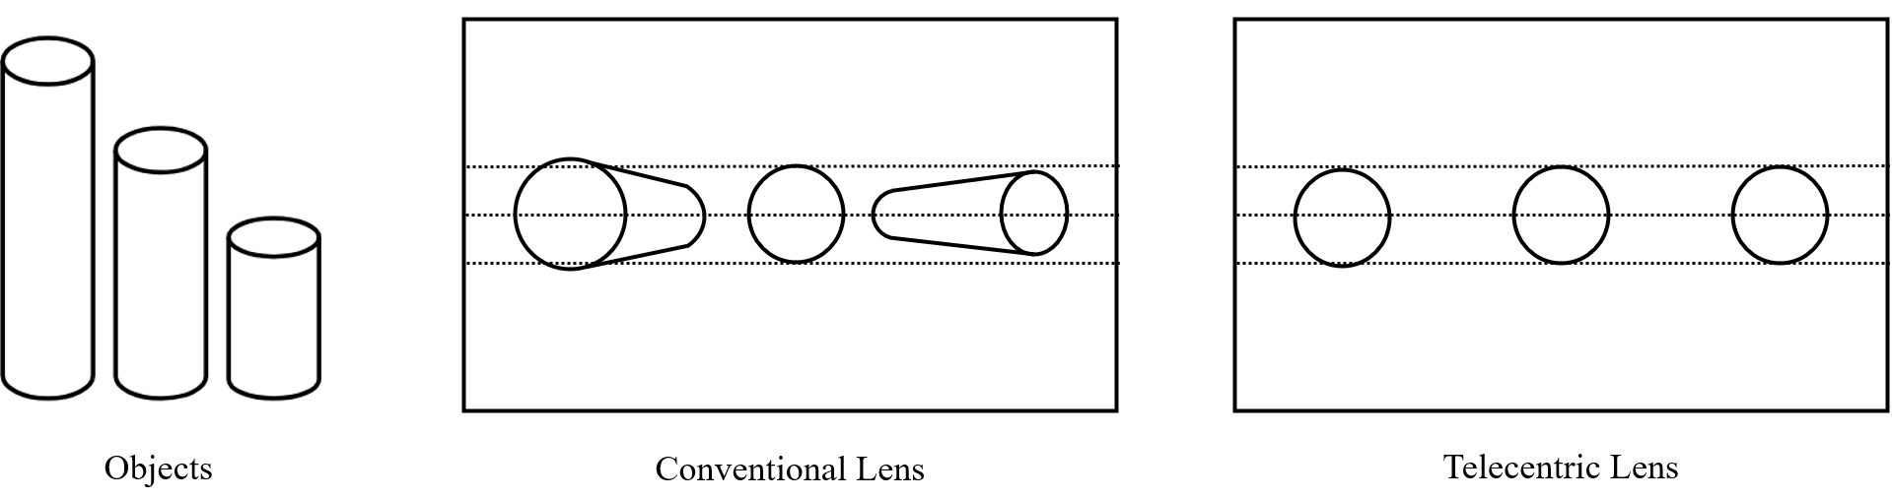

**Figure 2. Perspective Distortion**

To calculate height value precisely, objects need to be captured as the same size regardless of the height differences. If each object is disotrted according to the different height, the 3D scanning result from the laser triangulation method would be distorted.

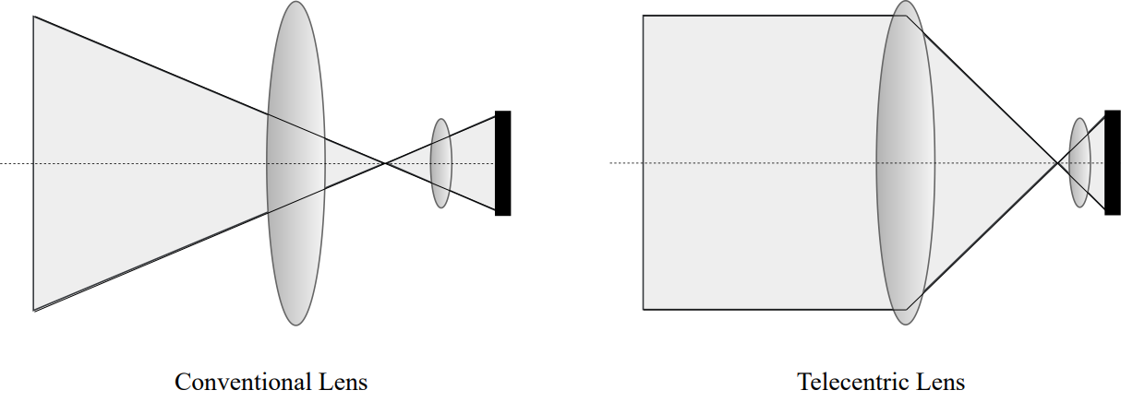

**Figure 3. Schematic Principle of Telecentric Lens**

To solve this problem, telecentric lens need to be used with 2D camera. With telecentric lens, small object can be captured with no perspective distortion.

**2.2. 3D Scanning System**

In this 3D scanning system, several hardwares were used to build up environment for applying the triangulation method, and several steps of software were built up to realize 3D scanning.

2.2.1. Hardware

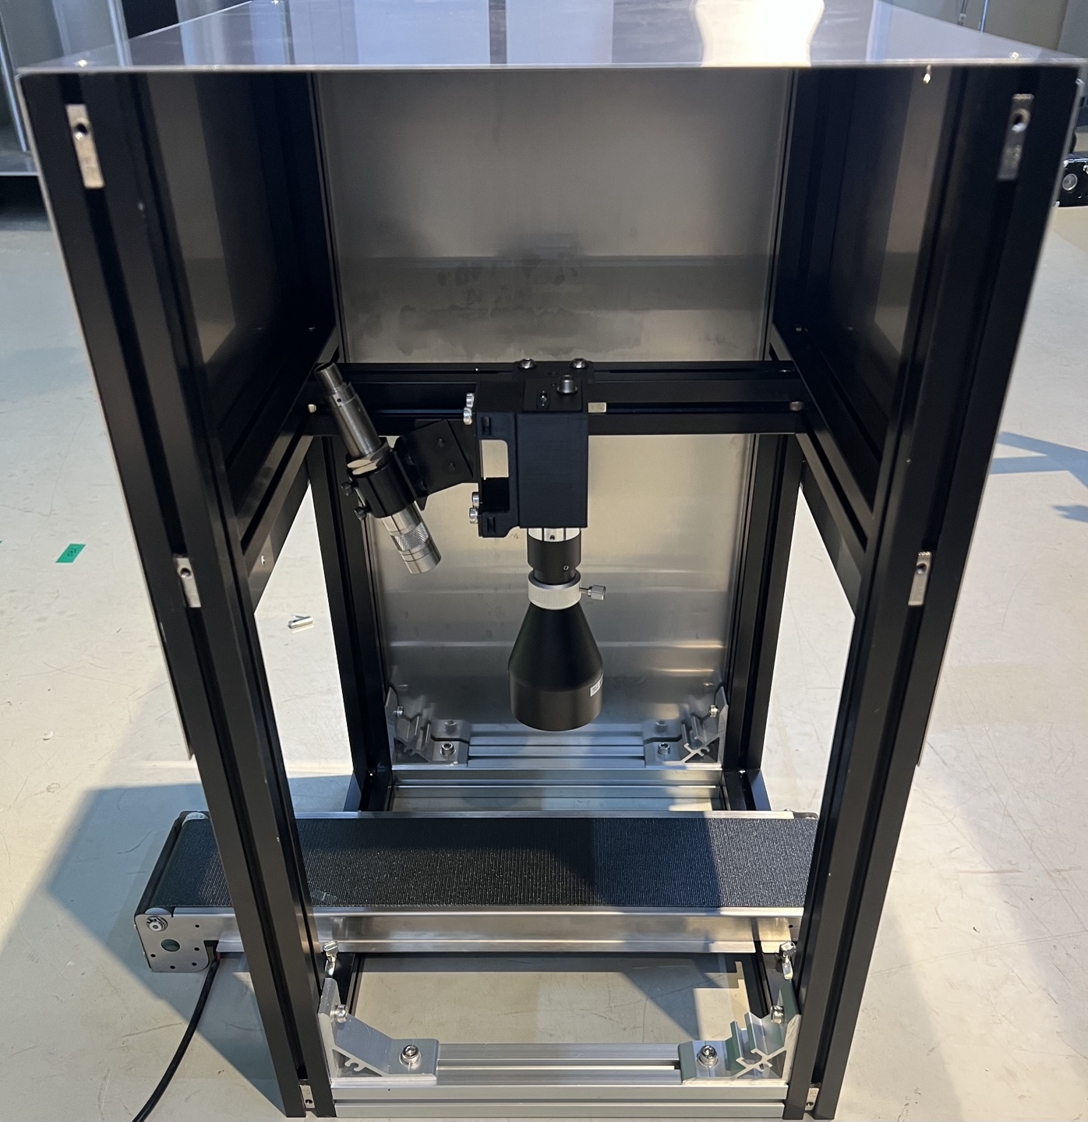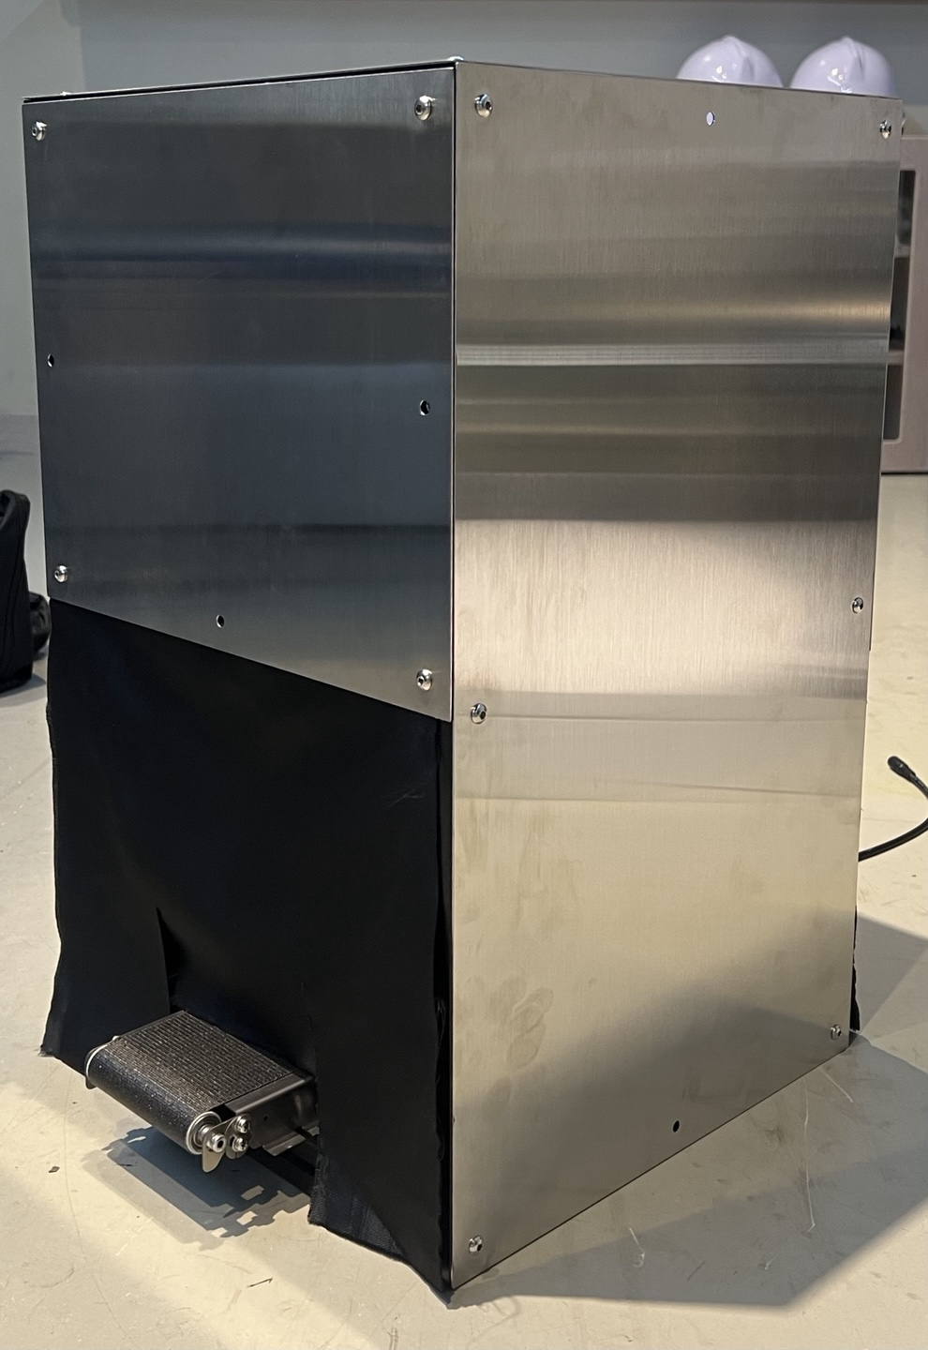

**Figure 4. Overall Hardware Setting**

To calculate height by using the laser tirangulation method, the four types of equipments need to be used in this project: 2D Machine Vision Camera, Telecentric Lens, Line Laser, and Conveyor Belt. 2D Camera and Telecentric Lens are combined to capture non-distorted images. At the left side of the camera, the line laser is fixed at specified angle and position. In addition to this, to pass each object under the lens and line laser, conveyor belt was fixed at the bottom. The whole case was made to block the outside light disturbance.

**Table1. Hardware Specifications**

|  |  |  |
| --- | --- | --- |
| Type | Name | Specification |
| 2D Camera | GS3-U3-41C6NIR-C | Resolution: 2048x2048  Pixel size: 5.5 µm x 5.5 µm  Image sensor size: 11.26 mm x 11.26 mm |
| Telecentric Lnes | TCL0.3X-130I-HR | W.D [mm]: 130  MAF: 0.3X  Telecentricity [°]: 0.04 |
| Line Laser | ZX20 | Wavelength: 450nm  Line width: 0.1mm at 350mm distance |

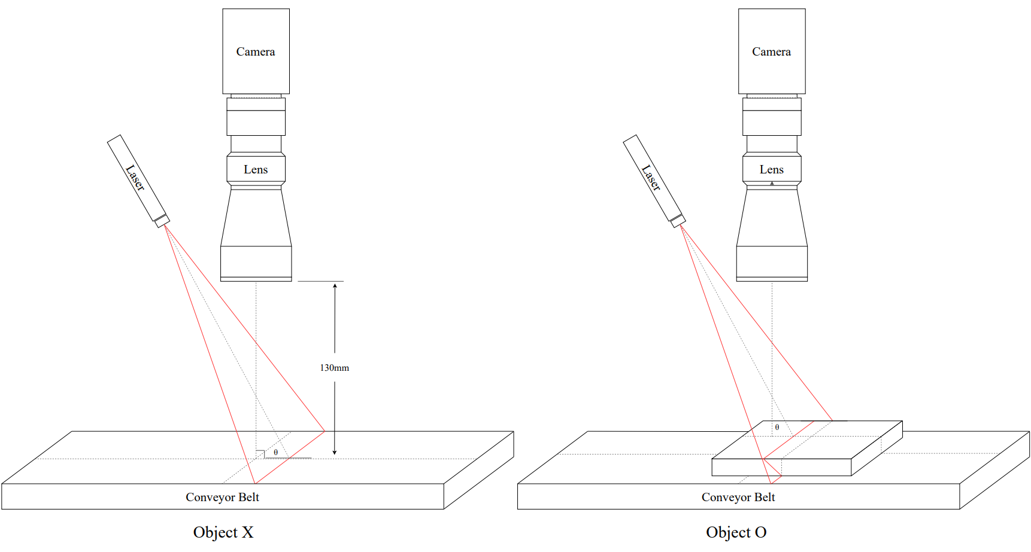

**Figure 5. Line Laser Setting, $θ: 70.5°$**

In this project, the line laser was fixed at $70.5° (θ:70.5°)$, and the telecentric lens was fixed at the distance of 130mm from the botton of the conveyor belt. Because the line laser was fixed at inclined angle, when some objects are passing under the lens, the line laser would be moved from the initial parallel location.

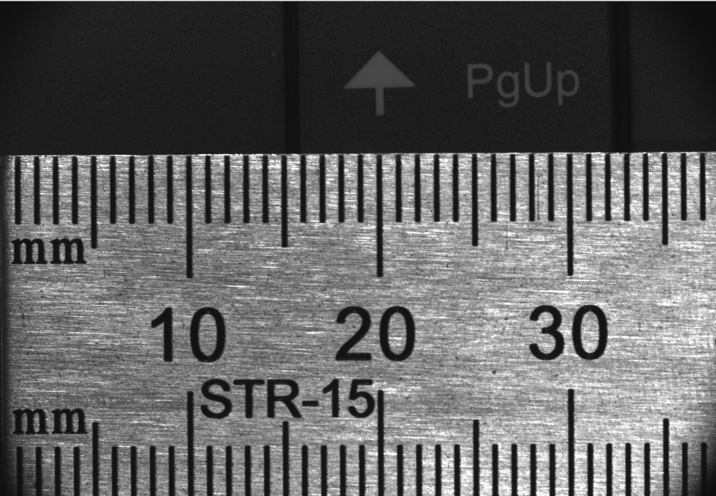

**Figure 6. Field of View, 37.53mm x 37.53mm**

In addition to this, because 2D camera’s image sensor size is 11.26 mm x 11.26 mm and telecentric lens’ MAF (magnification) is 0.3X, the Field of View is calculated like this:

$$FOV=(Image Sensor Size)/MAF=(11.26)/0.3[mm]=37.53[mm]$$

2.2.2. Software

In this project, python was used to build up software system. Especially, to use machine vision 2D camera in the python environment, Pyspin library must be used. To install Pyspin, Spinnaker SDK need to be installed at first. This program can be obtained from the Spinnaker website.

**Table2. Software Setting**

|  |  |
| --- | --- |
| Software | Version |
| Python | Python 3.8.20 |
| Spinnaker SDK | SpinnakerSDK_FULL_2.6.0.160_x64 |
| Pyspin | spinnaker_python-2.6.0.160- |

To get the 3D scanning result in the python environment, three steps of processes need to be performed: image capture, image processing, and plotting 3D scan result.

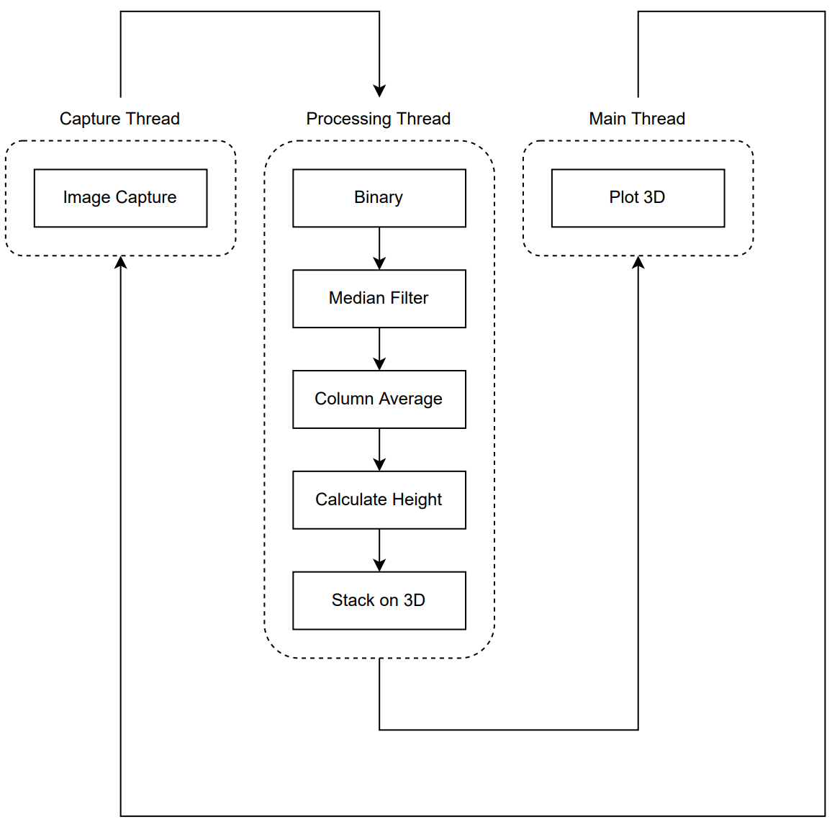

**Figure 7. Software Mechanism**

The maximum resoltuion of the image sensor of the 2D camera is 2048x2048. With this level of the resolution, each pixel would be able to express $0.02[mm]$. Although the higher resolution makes the smaller unit of distance per each pixel, because of the lack of memory which the 2D camera can sustain temporarily to prevent delayed uploading of images captured, I decided to resize the resolution of source image from 2048x2048 to 375x375. By doing this, the unit distance which each pixel would be able to express is decreased from $0.02[mm]$ to $0.1[mm]$. After downgrading the resoultion, this system did not experience the lack of memory when plotting 3D scanning.

In addition to this, to avoid the lose of images which would be captured duing the image processing and the 3D plotting processes, the ‘image capture’ process has been performed at seperated parallel thread. This thread makes ‘image capture’ process to be performed in parallel. As a result of this, every images caputred by 2D camera would be sent into next process without delaying. Further more, I built up every processes of this system to be performed in each seperated thead. By doing this, the speed of the overall 3D scanning system was able to be increased.

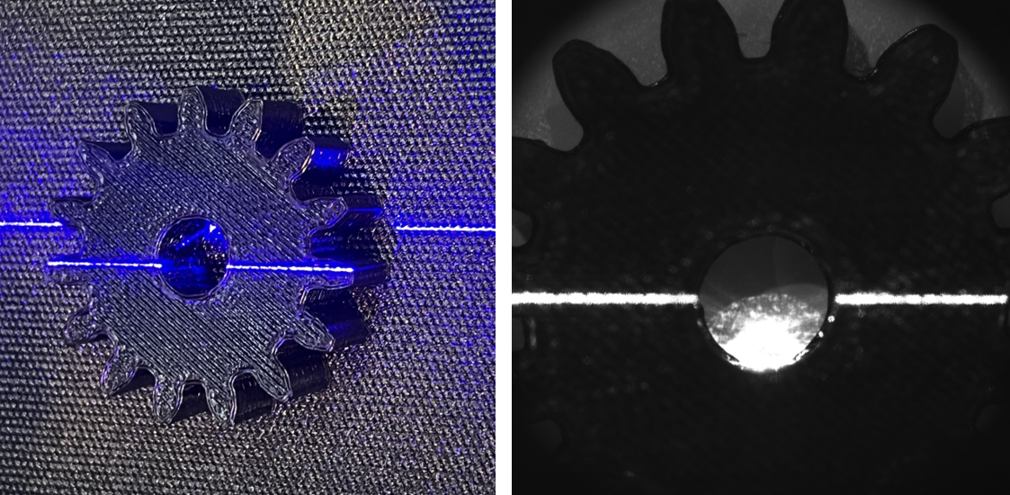

**Figure 8. Image Capture (Left: Srouce Image, Right: Gray Image)**

For example, after placing gear part on the conveyor belt, the gear would pass accross the line laser. While the gear has been moved on the conveyor belt, 2D camera would capture source images in the 375x375 resolution. After capturing each image, image processing needs to be performed to prepare the environment for calculation of each height. At first, source image need to be changed to gray scale. If there are adequate band pass filter of 450nm wavelength for the telecentric lens of 52mm diameter, the gray scale process would not be necessary. However, because I could not find the band pass filter of 450nm for this lens, this converting process needs to be used to highlight the light of the line laser. After converting source image into gary scale, each gray point would contain it’s own brightness value from 0 to 255. The brightness value is proportional to 0 to 255.

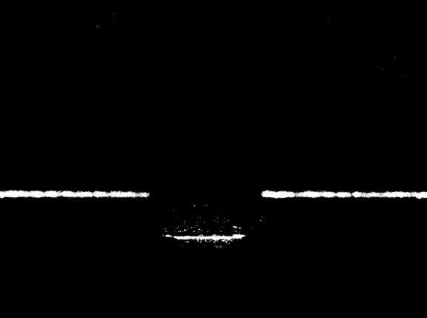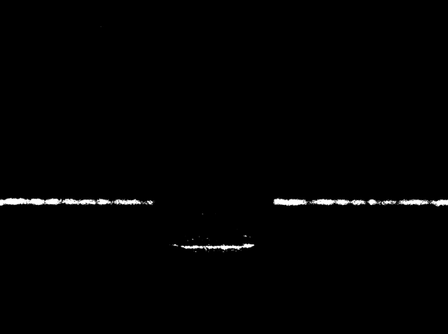

**Figure 9. Image Processing (Left: Threshold, Middle: Filtering, Right: Average)**

Because the line laser is projected on the conveyor belt with maximum power of 250mW, every points of line laser would be brighter than other points. The brightness value of the line laser would be much bigger than other points. For this reason, I decided to pass only some points which are over 250 value of brightness to pass only line laser’s points. After this process, the points over 250 brightness were converted into 255 value, and other points obtained 0 brightness value. By doing this, I could highlight only the line laser’s points with 255 value. The left side of the Firgure 9 is the result of first filtering process about brightness.

After this filtering, other optical informations would be almost removed, and only line laser informations would remain. However, becuase scattering of the line laser, there are some noises around the laser. Although the optical 3D scanning method can provide the most precise scanning result, lights are scattered depending on the material of surface. Although median filtering does not handle images delicately, I decided to use this filter to remove optical noises, because the center line of the laser would not be damaged from this filter. After median filtering, almost optical noises were removed. (Middle of Figure 9).

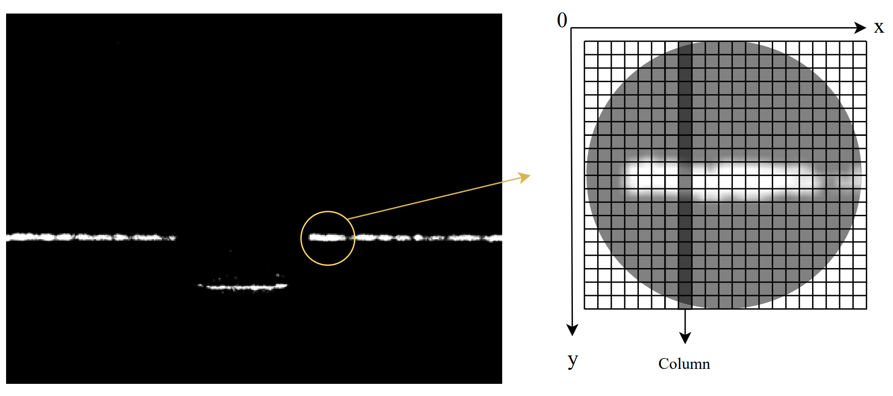

**Figure 10. Average each Column**

However, even if the line laser is projected as very thin line, the line does not consist of only one point in each column. In fact, there are several points in each column of line laser. To calculate height value with the displacement distance of the line laser from the initial parallel line, it is necessary to convert several points of the same column into one point. By doing this, the line laser would be marked as a point in each column. To make each column to have only one point, I decided to average y coordinate values of each column. After this process, I could convert the line laser points into fine line. (Figure 10’s Right section).

After all of these image processing, the number of points between the line laser and the initial parallel line were able to be counted. With the number of pixels, (N), each height value was able to be calculated like this:

$$Height_{n}=\frac{FOV}{Total Number of Pixels}*number of pixels of displacement*tan\left(70.5°\right)$$

$$=\frac{37.53\left[mm\right]}{375}*N*tan\left(70.5°\right)=N*0.28[mm]$$

After calculating height value 375 times, the single 2D image would be obtained. In this way, as repeating to generate and stack each 2D image on the x axis up to the end of the gear, 3D scanning result would be performed like this:

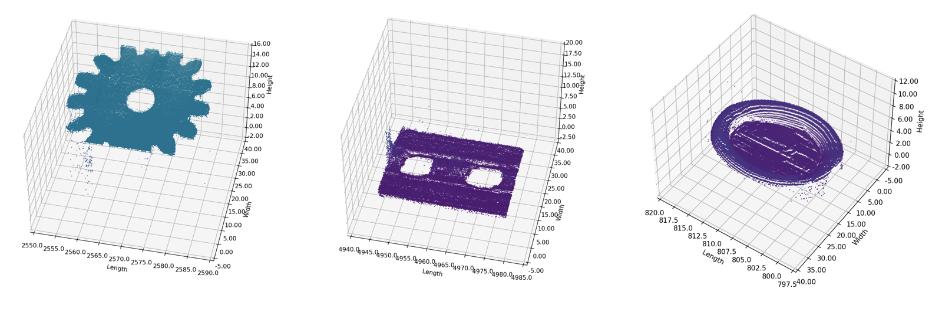

**Figure 11. 3D Scanning Results: Gear, Flat Joint, and Cap**

The left side of Figure 11 is for the gear. Because size of the gear is over FOV, part of the gear was not scanned. However, flat surfaces of the gear are scanned well. In addition to this, the flat joint and cap were also scanned in the same way of the gear. The middle side of the Figure 11 is 3D scanning result of Flat Joint, and Right side is Cap. Similar to the case of the gear, the flat surface of the joint was also scanned well. Further more, the incline surfaces of the cap are seemed to be reflected on the result of 3D scanning well. However, in fact there is a problem with scanning the inclined surface. The angle distortion would be dealt with on the limitations pages.

**III. Result of Experiment**

**3.1. Defect Inspection**

To check the performance of defect inspection of industrial small parts, I decided to compare the 3D scanning results of gear and frame of normal condition and defective condition.

3.1.1. 3D Scanning Result

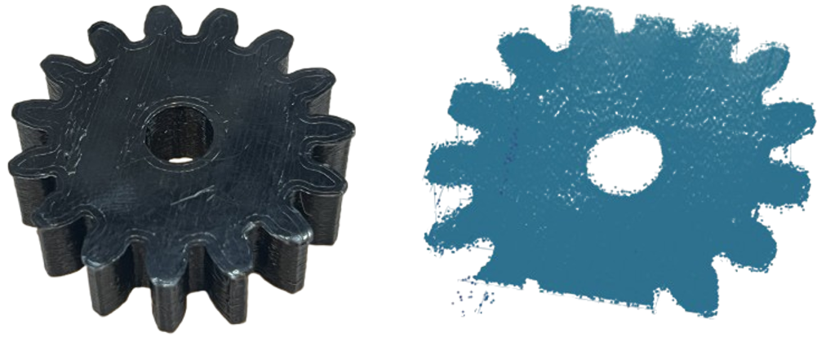

**Figure 12. 3D Scanning Result (Left: Real Gear, Right: 3D Scanning Result)**

The left side of Figure 13 is for the rear gear of normal state, and the right side is for the 3D scanning result of this gear. Although some parts of the gear were cut off becuase the size of gear exceeded the FOV, this 3D scanning captures the overall shape of the gear well.

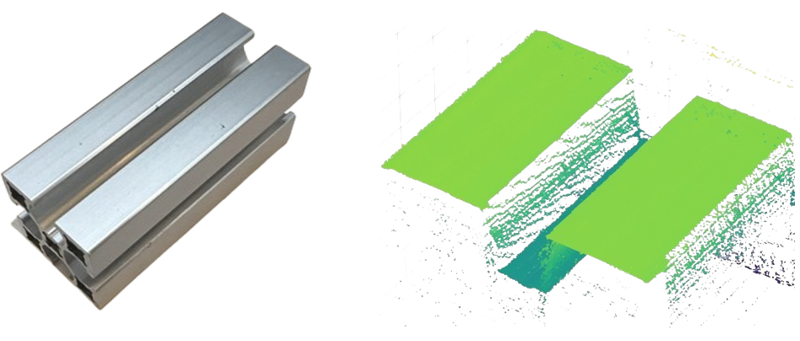

**Figure 13. 3D Scanning Result (Left: Real Frame, Right: 3D Scanning Result)**

To check the overall performance of the 3D scanning system, I used frame as another example of industrial part. The above flat side is seemed to be scanned well. However, the hidden sides where line laser would not able to be projected on are not scanned well. This is the fundamental limitation of the laser triangulation method. Howver, the overall shape of this frame also was able to be scanned from this system.

3.1.2. Defect Inspection

The ultimate purpose of this project is to inspect defect of industrial small part. To compare the 3D scanning result of normal state and defective state of each industrial part, I made some defects on the gear and frame.

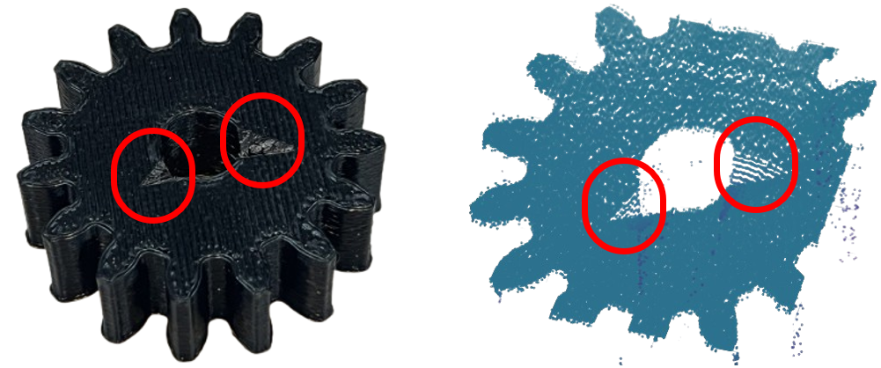

**Figure 14. Defect Inspection (Left: Real Gear, Right: 3D Scanning Result)**

I made two defects on the side of a hole of the gear. These defects are almost under the size of 5mm x 5mm. As you can see, these defects were included on the 3D scanning process well. However, because of the steep slope of these defects, they were scanned less tightly than when line laser was projected on the flat side of the gear.

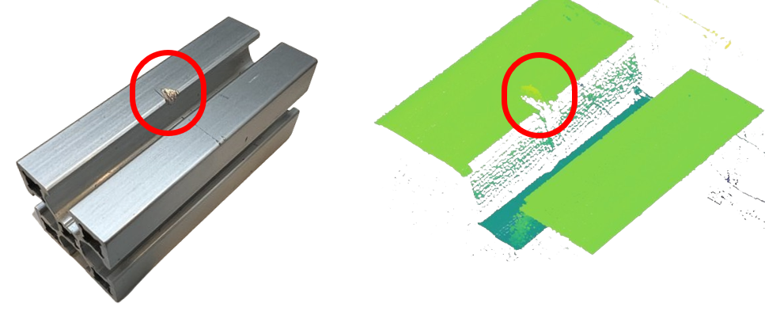

**Figure 15. Defect Inspection (Left: Real Frame, Right: 3D Scanning Result)**

I also made defect on the frame. This defect is almost under the size of 5mm x 5mm, and it’s slope was less steep than the gear. As a result of this, the defect of the frame was scanned more tightly than the gear. The changes of color according to different heights also can be observed. However, because there were hidden places where the line laser could not be projected on, some white spaces of 3D scanning were occured. In spite to this, I could inspect defect of each part generally.

**3.2. Limitations of This System**

3.2.1. Unit Distance between Each 2D Image

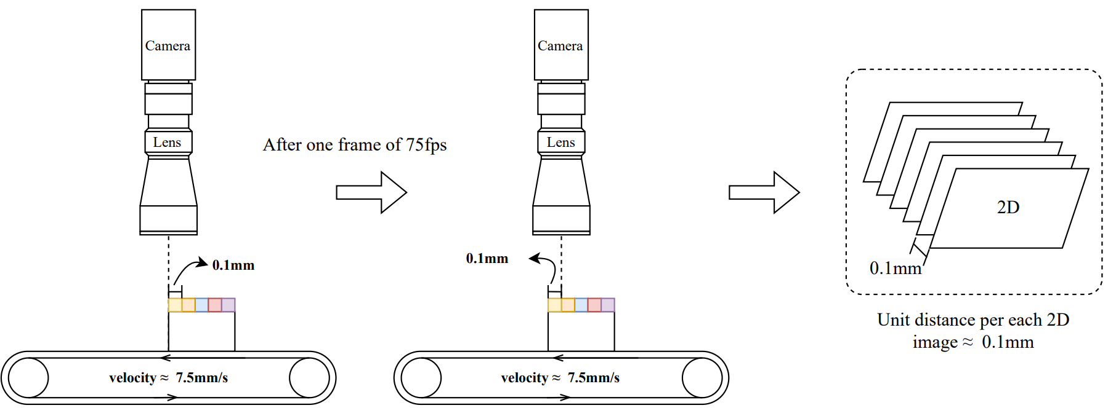

**Figure 16. Theoretical Unit distance between Each 2D Image ≈ 0.1mm**

In addition to the hidden area where the line laser would not be able to be projected on, there are several limitations of this 3D scanning system. The first limitation is to set up the unit distance between each 2D image. To make 3D scanning results, hundreds of 2D images need to be stacked on the x axis. And because the image capture process is performed on the seperate thread, each image would be captured every 1/fps seconds. Fot this reason, the unit distance between each frame would be calculated like this:

$$Unit Distance per Each 2D Image=(Velocity of Conveyor Belt)/(Current fps)$$

To calculate the unit distance between each frame, speed of the conveyor belt need to be measured accurately. When I measured the passing velocity of object on the conveyor belt, each object almost moved at a velocity of about 7.5mm/s. However, it seemed that speed of the conveyor belt is changed slightly depending on the current voltage. In addition to this, I could not check the accurate velocity in the scale of $um$ unit by using each image captured by 2D camera. In fact, to obtain the accurate unit distance between each frame captured, precise manipulation about the velocity of the conveyor belt need to be performed. However, becuase I applied conveyor belt to make movement of object too late, I could not find the adequate conveyor belt for this project. For this reaon, to enhence the accuracy of the 3D scanning about length value, other conveyor belt need to be applied for this project.

3.2.2. Slope Distortion

The laser triangulation method obtains height value from the displacement distance between primary line laser location and changed line laser location. This displacement of line laser is occured due to the projection of the line laser at a inclined angle. Although this inclination is the fundamental condition of this system, the inclination of the line laser makes slope distortion.

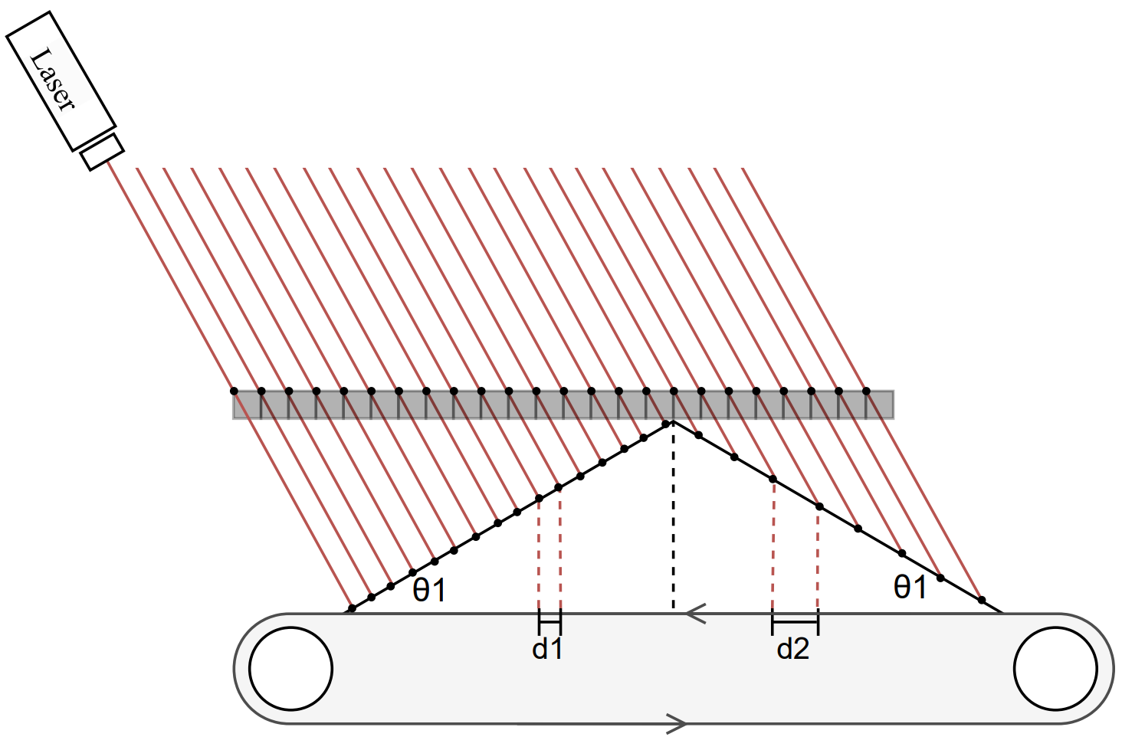

**Figure 17. Slope Distortion: d2 > d1**

The line laser would be fixed at predetermined angle and position. When flat surface passes the line laser, there are not distortion due to the angle of line laser. However, when there are inclined surfaces on the obeject, the object’s length would be distorted. Figure 18 shows that even if the conveyor belt operates at a constant speed, the distance between each point for each capturing is changed depending on the inclination of the object. When scanning the left of the object, the unit length captured by 2D camera would be d1. However, when scanning the right side of the object, the unit length becomes d2. As checking the distance of each value, d2 is bigger than d1, even though conveyor belt is working at constant speed. This disotrtion is occured due to inclination angle of the line laser. This disortion is the fundamental limitation of the laser triangulation method used in this project. For this reason, this system must be used to scan very small object which would have low level of height. Or to remove the angle distortion problem fundamentally, the locations of 2D camera and line laser need to be changed. If the line laser is fixed at the $90°$ of angle, angle distortion would not be occured.

**IIII. Conclusion**

In this project, the 3D scanning system was developed using the laser triangulation method. This method calculates the height of small objects by measuring the displacement distance of the line laser from its initial position. Accurate recognition of this displacement is crucial, so the system is enclosed with five plates to block ourside light distrubance. After blocking outside light, a 2D camera, telecentric lens, line laser, and conveyor belt would be used to scan each object. In this hardware setting, to realize the laser triangulation method for 3D scanning, the software system consisted of three steps: capturing 2D images, image processing (converting them to grayscale, and filtering using a threshold (250–255) and a median filter to remove noise and extract fine laser lines), and plot 3D scanning result.

Because each height value was able to be calculated precisely (almost 0.1~0.2mm precision), the overall shape of each object was able to be scanned in 3D. To achieve the fundamental purpose of this project, the inspection for defect of the gear and frame were able to be performed well with the result of 3D scanning. However, there are some limiations in this project. At First, the unit distance between each 2D image was not obtained precisely. This problem was occured from unstable speed of the conveyor belt. To obtain precise 3D scanning result, the new conveyor belt which can manipulate velocity precisely needs to be applied to this system. In addition to this, because of the inclined slope of the line laser, length distortion was occured. To solve this problem, the fixed angle of line laser need to be close to $90°$, and only small object need to be scanned by using this system. Although there are some limitations of this 3D scanning system, this system has the potential for accurate height calculation. With the 2048x2048 resolution of the 2D camera and the micrometer-thick of line laser, this system would be able to distinguish 0.05mm units.

**Reference**

[1] Automation Technology GmbH. (2021). *C5 series user manual for high speed 3D cameras* (Rev. 1.6). Automation Technology GmbH.